

INFORMATION NOTICE – Maitai Rangiroa Hotel

Dear Partners,
We are pleased to inform you that the Maitai Rangiroa Hotel will begin a major renovation project starting mid-January 2026. The work will continue throughout the year 2026, carried out in phases to ensure the best possible comfort for our guests.

- Phase 1: Renovation of the lagoon bungalows -January 15 /May 15
- Phase 2: Renovation of the premium garden bungalows -April1 /Sept 15
- Phase 3: Renovation of the garden bungalows August 20/ Dec 31

Please note that the hotel will remain open during the entire renovation period, and every effort will be made to minimize any inconvenience related to the works.
All public areas – including the reception, restaurant, and bar – will remain fully operational, with no change to their regular opening and closing hours.
This necessary renovation will bring more brightness and a subtle contemporary touch, while above all preserving the local Maitai identity that makes our property so unique.
We thank you for your continued support and trust, and we will be sure to keep you informed of the progress of this exciting project.

With kind regards,
Hotel Management & Services – Maitai Rangiroa Hotel

BEFORE
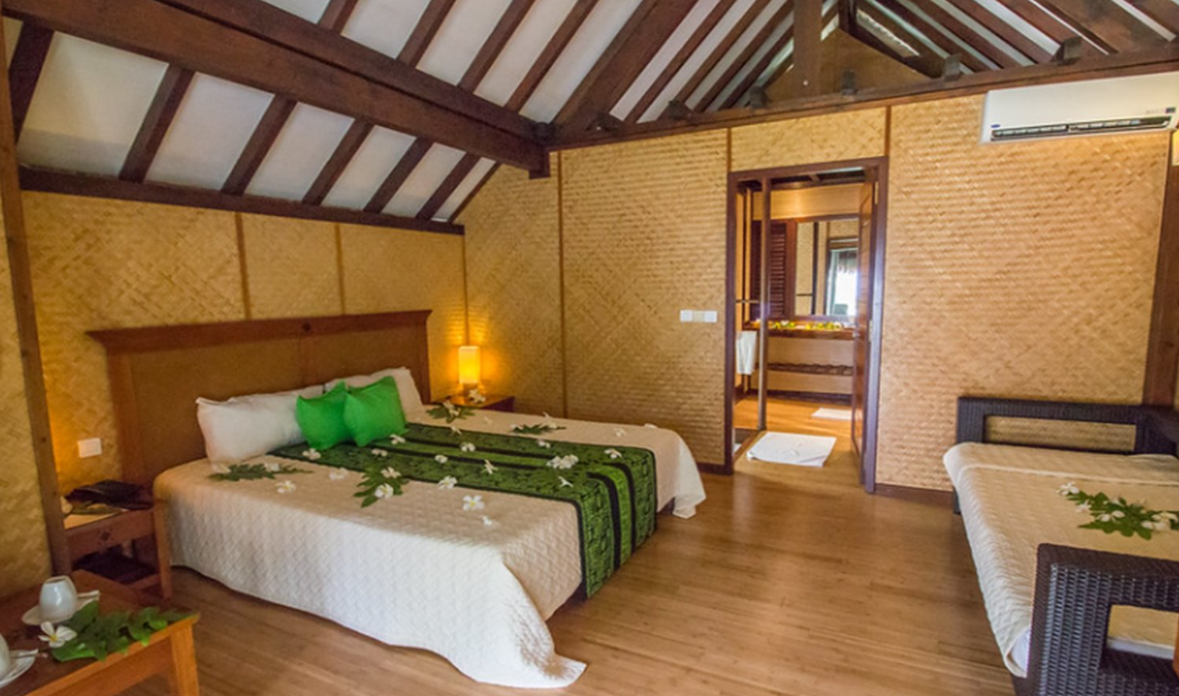

AFTER
